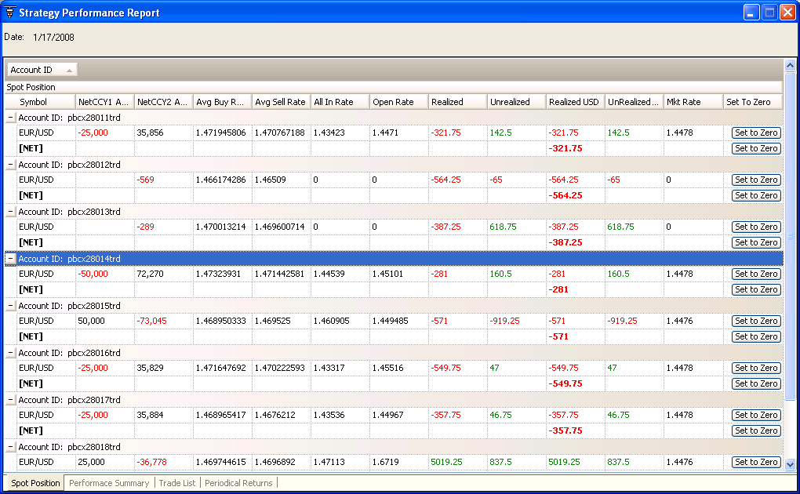

At StrategyPerformanceReport.vb :: line 329 :: Private Sub UpdateRow(ByVal r As DataRow, ByVal dr As DataRow)
At StrategyPerformanceReport.vb :: line 303 :: Private Sub UpdateDSSpotPosition(ByVal r As DataRow)
At StrategyPerformanceReport.vb :: line 287 :: Private Sub trader_PLCalculation(ByVal dr As DataRow) Handles plcal.PLCalculation
At PLCal.vb :: line 16 :: Public Sub CalculatePIPS(ByVal tradeData As TradingInterface.Fill)
At Components/AlertExecution.vb :: line 335 :: Private Sub CalculatePLTrade(ByVal f As TradingInterface.Fill)
At Components/AlertExecution.vb :: line 202 :: Private Sub ex_OrderFilled(ByVal f As TradingInterface.FFillOrder, ByVal fdata As TradingInterface.Fill) Handles ex.OrderFilled

